Name:Jeevan S U

**Name: Jeevan S U**

**Roll No: 241059038**

**Subject: Cryptology Lab**

**Program: M.E in Cyber Security, MSIS, MAHE**

1. Write a python script to get the binary values from the user and perform XOR operation. 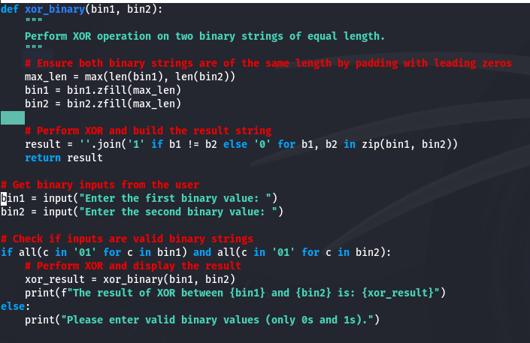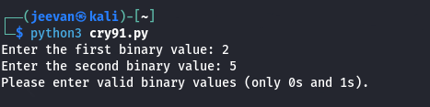
2. Write a Python script that implements a simple 4-bit LFSR. The initial state of the register and the tap positions should be user inputs. Simulate 10 steps of the LFSR, displaying the state of the register at each step.

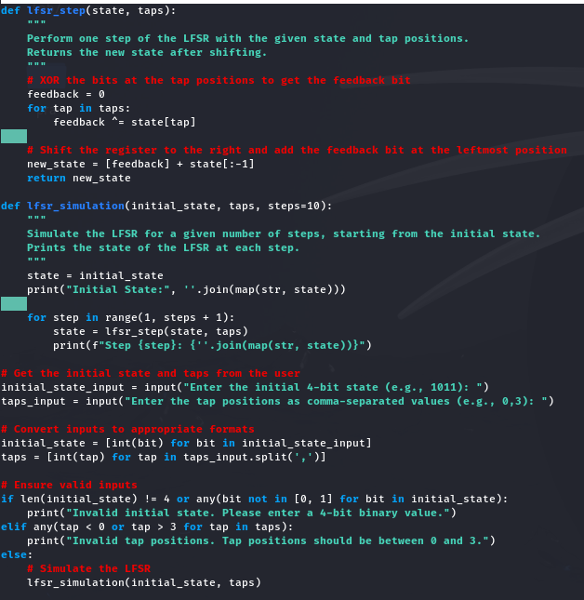

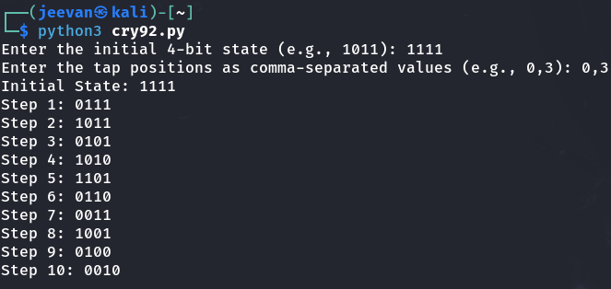

1. Write a report on attacks on LFSR. Explain any one attack in detail.

Report on Attacks on Linear Feedback Shift Registers (LFSRs)

**Introduction**

Linear Feedback Shift Registers (LFSRs) are commonly used in cryptography and communications for generating pseudo-random sequences. They are popular due to their simplicity and efficiency in hardware implementation. LFSRs produce deterministic sequences that appear random, but due to their linear nature, LFSRs are vulnerable to various attacks. Understanding these vulnerabilities is essential to secure cryptographic systems that rely on LFSR-based generators.

**Types of Attacks on LFSRs**

**1.** **Known-Plaintext Attack**: In this attack, if an attacker has access to both the ciphertext and the plaintext, they can potentially recover the internal state of the LFSR or the key stream generation function.

**2. Correlation Attack**: This attack leverages the correlation between the generated keystream and the output of one or more individual LFSRs in a combined stream generator. By exploiting this correlation, the attacker can retrieve the LFSR's state and deduce the key stream.

**3. Algebraic Attack**: In algebraic attacks, the attacker uses algebraic equations derived from the LFSR to reconstruct the key or the initial state. This attack is especially effective against stream ciphers that rely on LFSR-based sequences.

**4. Berlekamp-Massey Algorithm Attack**: This algorithm is commonly used to reconstruct the LFSR configuration by observing a finite portion of the output sequence. Once the configuration is known, the entire sequence becomes predictable.

**5. Time-Memory Trade-Off (TMTO) Attack**: This attack involves precomputing possible LFSR outputs and storing them in a lookup table. An attacker can then reduce the complexity of cracking the LFSR-based generator using this precomputed information.

**6. Divide and Conquer Attack**: This type of attack is effective on multi-LFSR stream generators where the outputs of several LFSRs are combined. The attacker targets each LFSR individually by isolating their contribution to the overall stream.

**Detailed Analysis: Correlation Attack**

The correlation attack is one of the most effective attacks against LFSR-based systems, especially those using multiple LFSRs combined to form a stream cipher. In many LFSR-based cryptosystems, several individual LFSRs are combined using Boolean functions to generate a complex, pseudo-random key stream. The correlation attack targets these systems by exploiting any correlation that exists between the generated key stream and the output of one or more LFSRs.

**How Correlation Attack Works**

1. Identify Correlations: A correlation attack starts by identifying correlations between the final key stream and individual LFSRs. For example, if the output of an individual LFSR has a high probability of matching a certain bit in the key stream, then this LFSR can be a target for the attack.

2. Use of a Hypothetical State: The attacker makes an educated guess about the initial state or partial state of one of the LFSRs. By simulating the LFSR with this hypothetical state, the attacker generates a sequence and checks it against the observed key stream for matches.

3. Statistical Analysis: By repeating this process for various guesses, the attacker builds up statistical information about which guessed states produce key stream bits with a correlation close to the expected value. If a guessed state frequently aligns with bits in the key stream, it is likely close to the true initial state.

4. Refining the Attack: Once a promising candidate for the initial state is found, the attacker can refine their approach to recover the entire LFSR state. With one LFSR state known, the attacker can proceed to deduce the other LFSRs in a similar way if multiple LFSRs are used.

1. Reconstructing the Key Stream: After finding the initial state(s), the attacker can then reconstruct the entire key stream or use it to decrypt any ciphertext encrypted with the same stream cipher.

**Conclusion**

Correlation attacks highlight the vulnerability of LFSR-based stream ciphers that rely on simple combination functions. While LFSRs are highly efficient in generating pseudo-random sequences, their linear nature makes them susceptible to various cryptographic attacks. Proper design using nonlinear combination functions, longer LFSR lengths, and other countermeasures can help mitigate the risk posed by correlation attacks and enhance the security of LFSR-based cryptographic systems.